DocNo: 001.F.1.1

**Grape**

**User’s Guide**

**Version 1.0**

**By**:

Group Undefined

2015-04

**Group Member**:

Hunter Lin

Birdy

Listen

Morning

Syachi

**Document Language**:

English

**Revision History**

|  |  |  |  |
| --- | --- | --- | --- |
| **Date** | **Version** | **Description** | **Author** |
| 2015.4.12 | 1.0 | Initialization of the report | Hunter Lin |
| 2015.4.16 | 1.1 | Finished the part of usage | Morning moni |
| 2015.4.18 | 1.2 | Finished the part of output | Listen |
| 2015.4.22 | 1.3 | Finished the part of input | Birdy Zhou |
| 2015.5.03 | 1.4 | Finished the part of … | Syachi |
| Final Date | 2.0 |  |  |

### 2.3Security

The Grape is secure for we divide users into different roles. Different roles lead to different authority, which brings order to our system. A member will not have advanced authority like raising a vote, which only belongs to a leader. And none of the users is able to act as an admin to access to the database.

### 4.2.2Input Format

We have some confines for the input format:

1. Length:

Group name/username: less than 20 characters

Date: YYYY/MM/DD

Title of vote/question: less than 50 characters.

Content of vote/questions: less than 150 characters.

1. Format Standard:
   1. Grape doesn’t force user to follow the format standard. But we recommend some format standards:
   2. All the input data shall keep with the left of text field, without any blank.
   3. The data in the text field shall be composed of alphabet, digit and some usual symbols. Don’t input some unusual symbols.
   4. The length of data shall not beyond the constraint.
   5. All the input shall truly reflect the information of projects or bugs in real world.

## 4.2.3Instance for Inputting

Here we present the instance for inputting, taking the module ’sign up’ for example. In the module, we need to input our email, username, password, and confirm our password. If we give an invalid input, the submit button will be locked. and it will be unlocked until we give it a valid input.

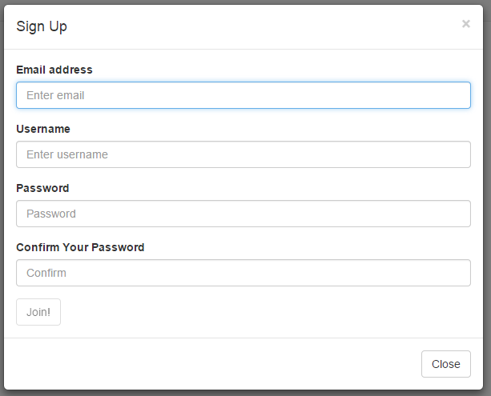

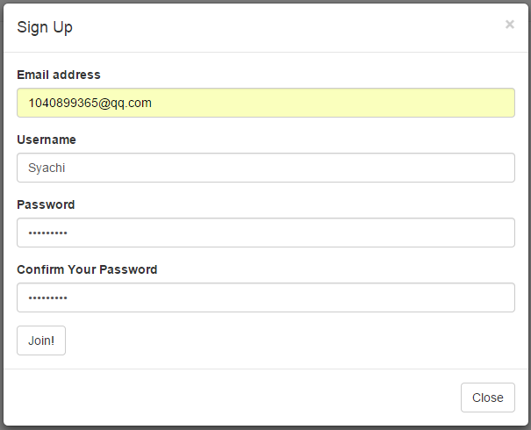

## 4.3.2Output Format

We have some confines for the input format:

1. Index

Index should contain basic information for different kind of users.

* 1. For those who has logged in, index should contain some information about their groups.
  2. For those who has not logged yet, index should contain basic introductions to our project.

1. Voting page

Voting page should perform different output for different users.

* 1. For group leader, he can see the info of the vote, and has a button to end the vote immediately.
  2. For group members, they can choose vote selections.

1. Asking page

Asking page should contain title and text of the question, and answers.

## 4.3.3Instance for Outputting

The output is the form of HTML files. Take an instance for users’ index:

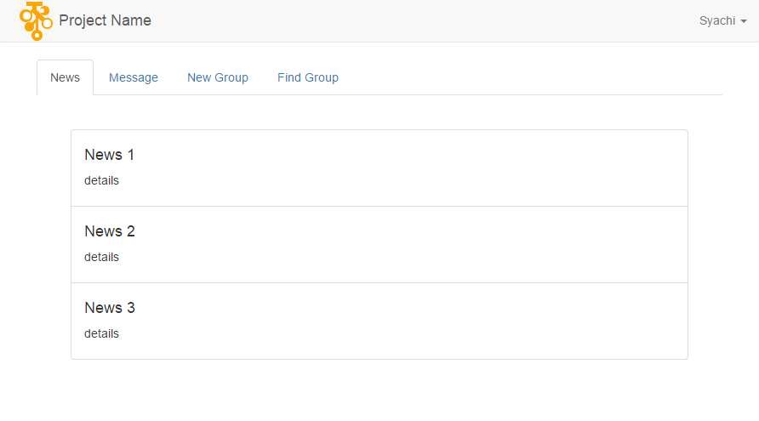

It contains some news of the user’s group. User can also check messages and find groups.

Other output forms will be given later..